**Practical No. 5**

1. **Write a PHP program to-**
2. **Calculate length of string.**
3. **Count the number of words in string -without using string functions.**
4. **Write a simple PHP program to demonstrate use of various built-in string functions.**

**Code (Pg no.70):**

<?php

    var_dump('PHP is string oriented');

    ?>

**Output:**

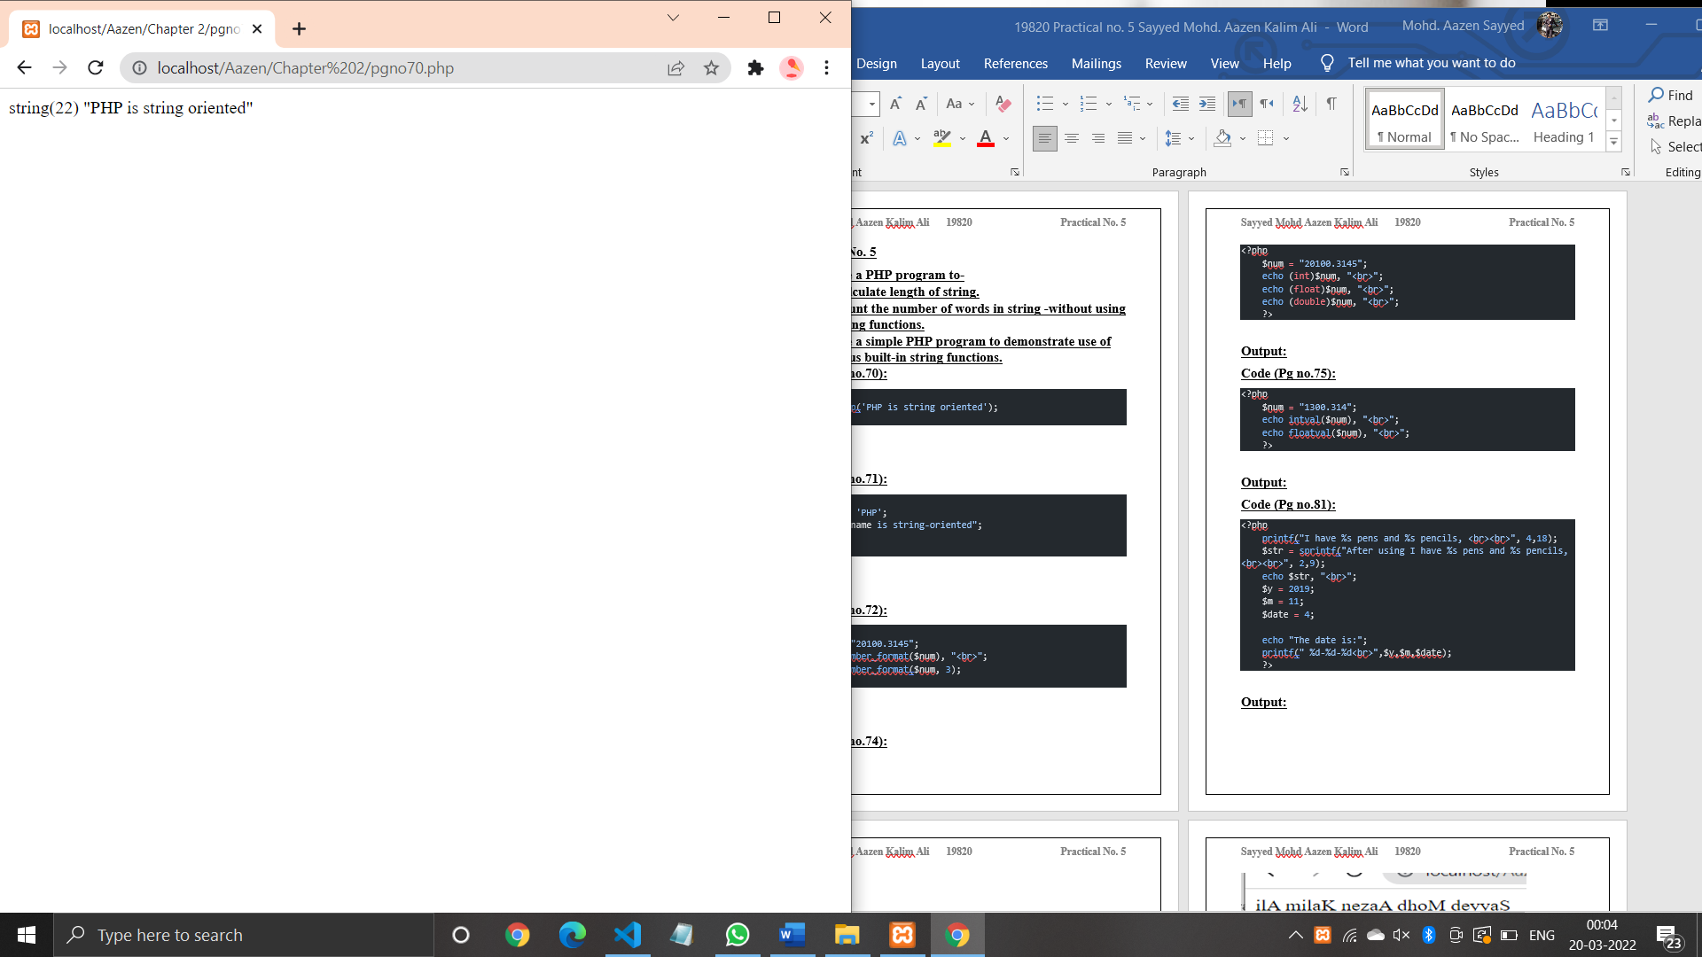

**Code (Pg no.71):**

<?php

    $name = 'PHP';

    echo "$name is string-oriented";

    ?>

**Output:**

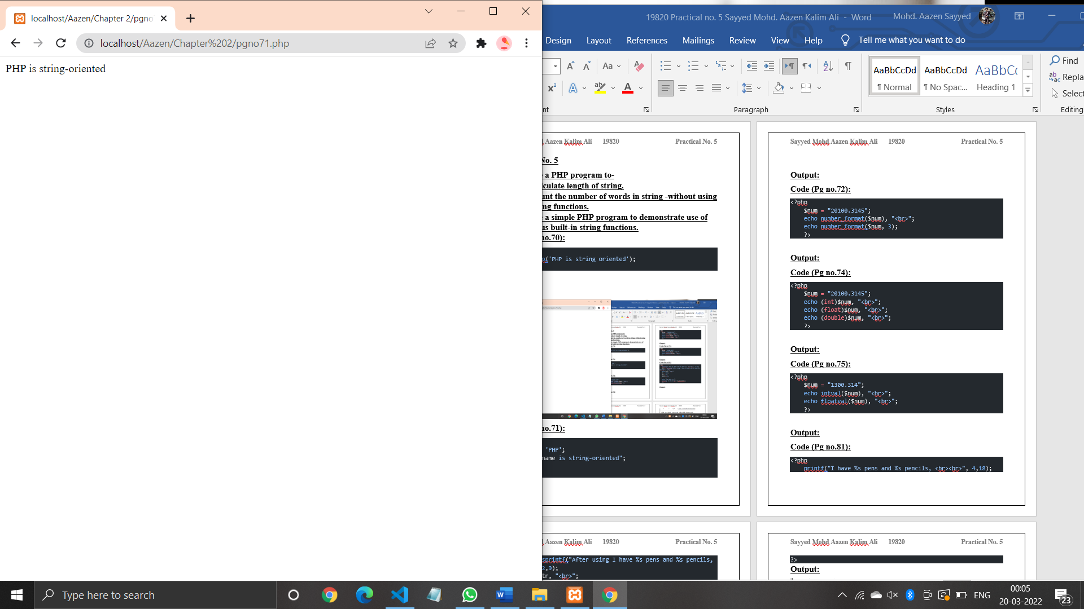

**Code (Pg no.72):**

<?php

    $num = "20100.3145";

    echo number_format($num), "<br>";

    echo number_format($num, 3);

    ?>

**Output:**

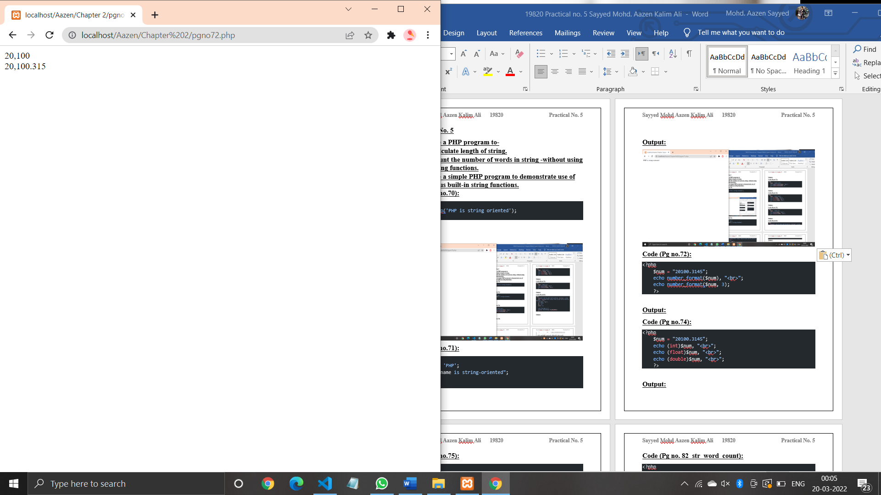

**Code (Pg no.74):**

<?php

    $num = "20100.3145";

    echo (int)$num, "<br>";

    echo (float)$num, "<br>";

    echo (double)$num, "<br>";

    ?>

**Output:**

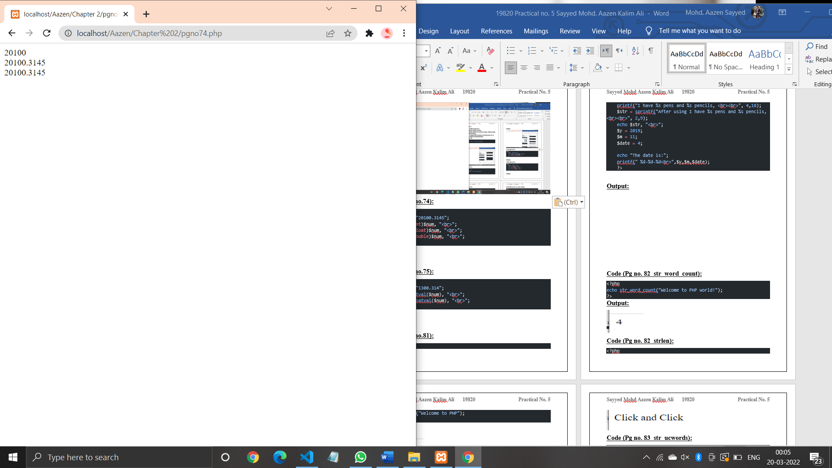

**Code (Pg no.75):**

<?php

    $num = "1300.314";

    echo intval($num), "<br>";

    echo floatval($num), "<br>";

    ?>

**Output:**

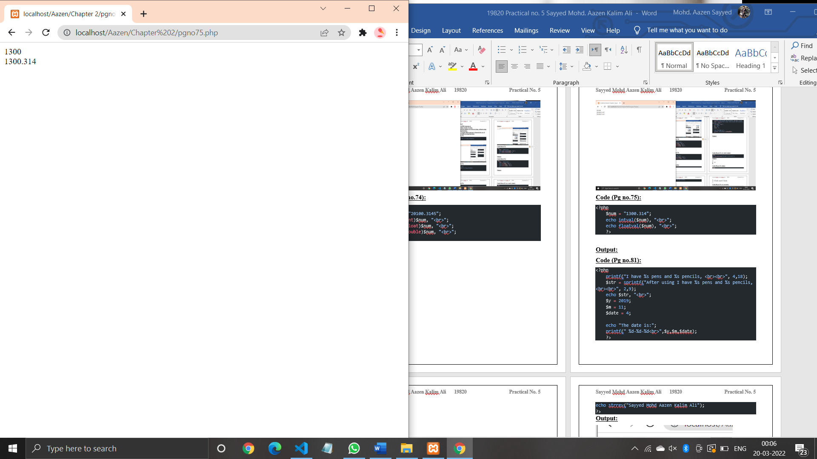

**Code (Pg no.81):**

<?php

    printf("I have %s pens and %s pencils, <br><br>", 4,18);

    $str = sprintf("After using I have %s pens and %s pencils, <br><br>", 2,9);

    echo $str, "<br>";

    $y = 2019;

    $m = 11;

    $date = 4;

    echo "The date is:";

    printf(" %d-%d-%d<br>",$y,$m,$date);

    ?>

**Output:**

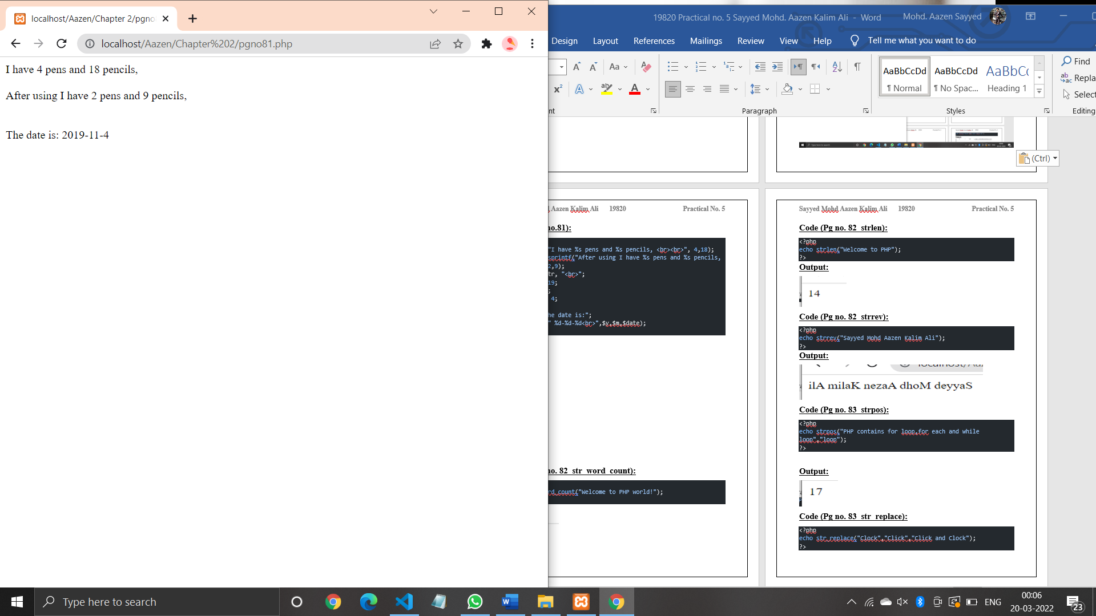

**Code (Pg no. 82_str_word_count):**

<?php

echo str_word_count("Welcome to PHP world!");

?>

**Output:**

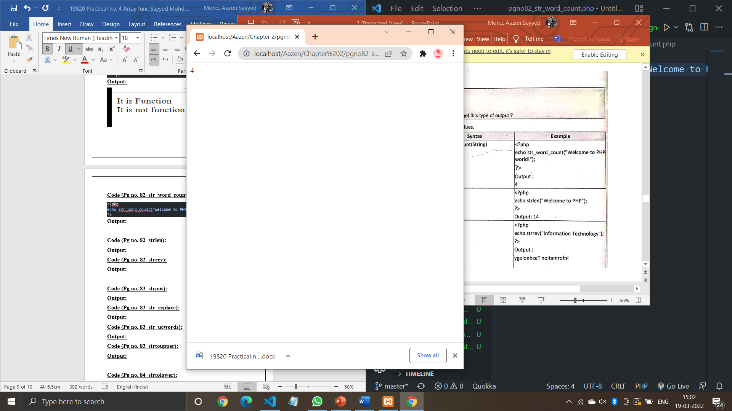

**Code (Pg no. 82_strlen):**

<?php

echo strlen("Welcome to PHP");

?>

**Output:**

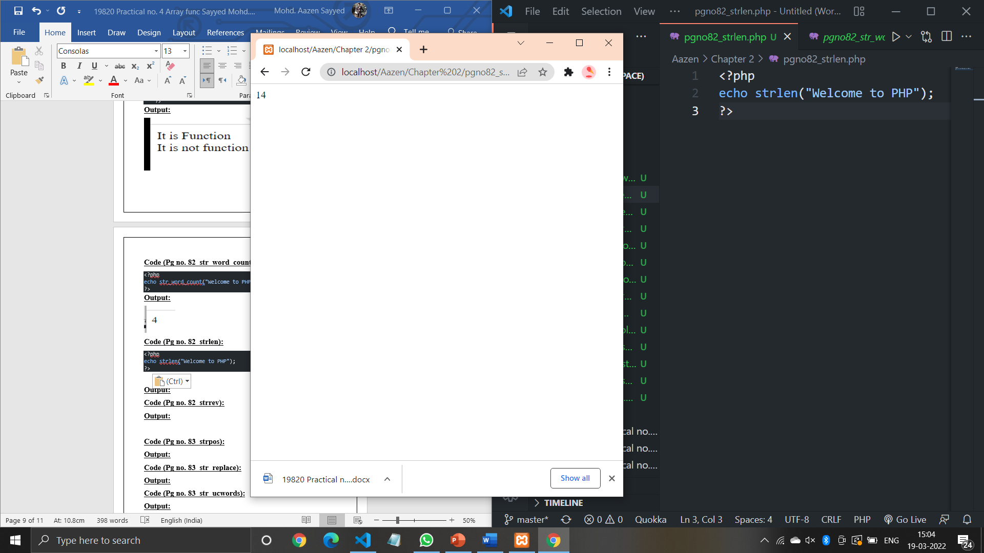

**Code (Pg no. 82_strrev):**

<?php

echo strrev("Sayyed Mohd Aazen Kalim Ali");

?>

**Output:**

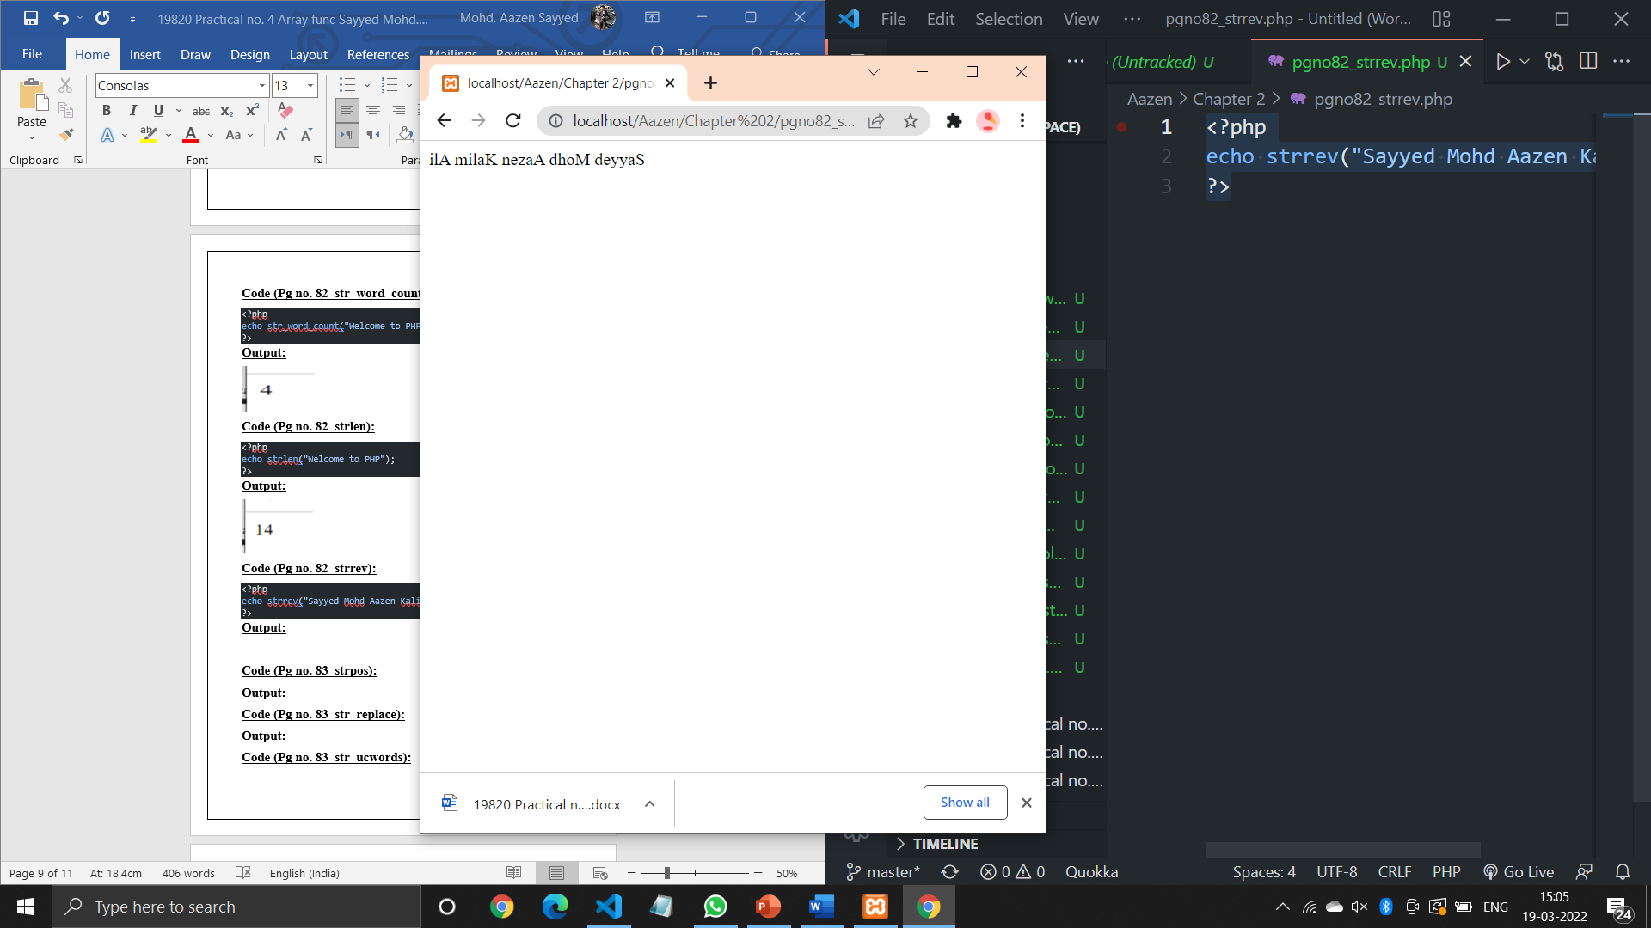

**Code (Pg no. 83_strpos):**

<?php

echo strpos("PHP contains for loop,for each and while loop","loop");

?>

**Output:**

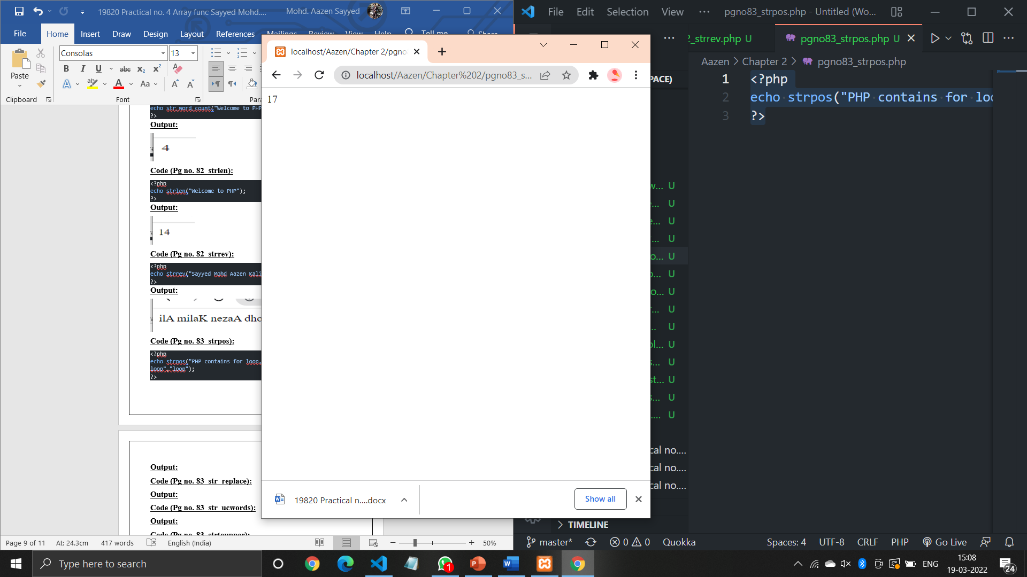

**Code (Pg no. 83_str_replace):**

<?php

echo str_replace("Clock","Click","Click and Clock");

?>

**Output:**

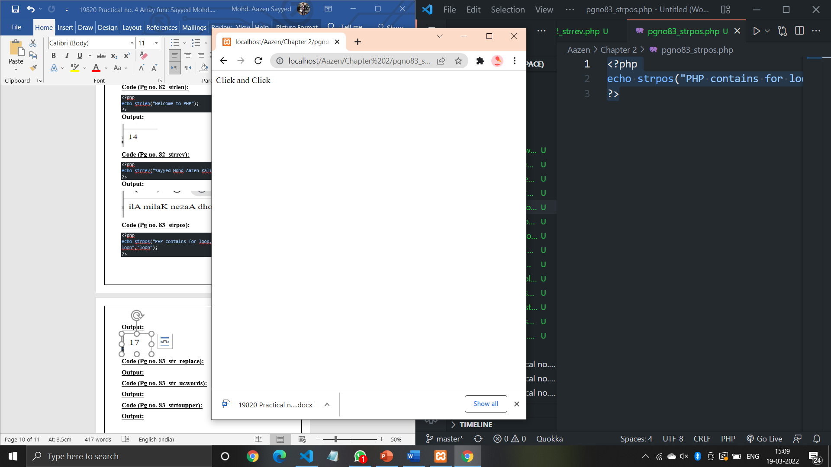

**Code (Pg no. 83_str_ucwords):**

<?php

echo ucwords("welcome to php world");

?>

**Output:**

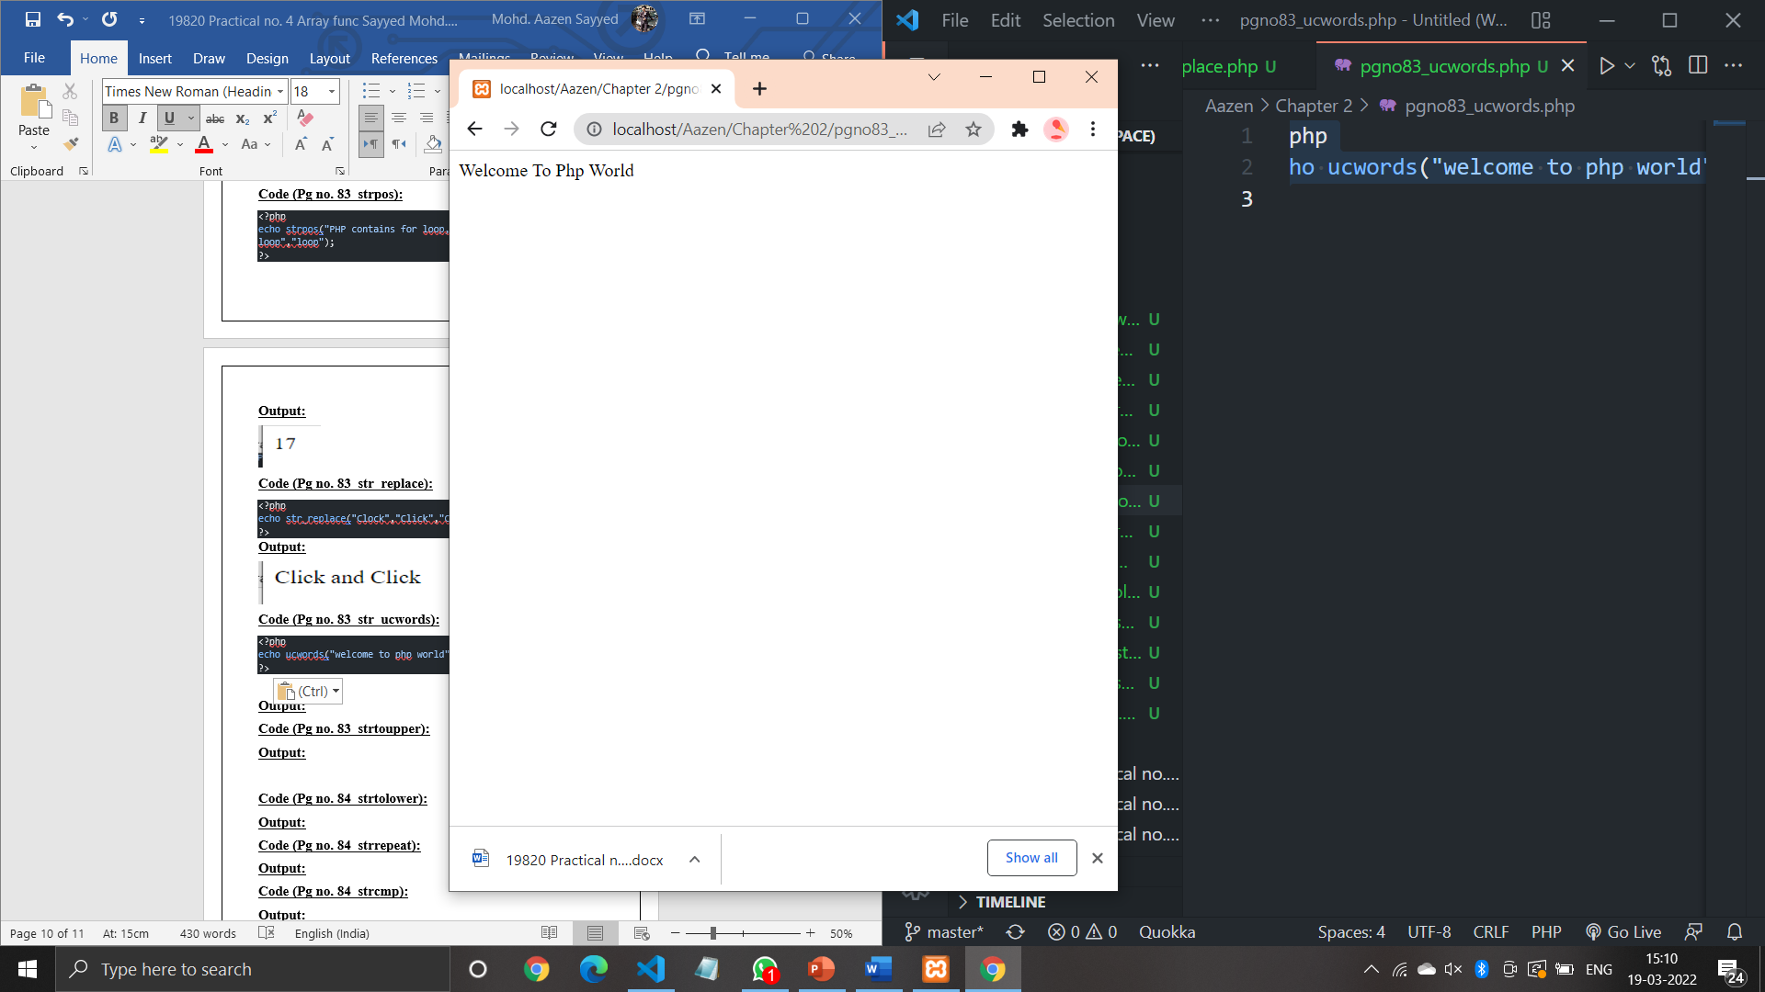

**Code (Pg no. 83_strtoupper):**

<?php

echo strtoupper("sayyed mohd aazen kalim ali");

?>

**Output:**

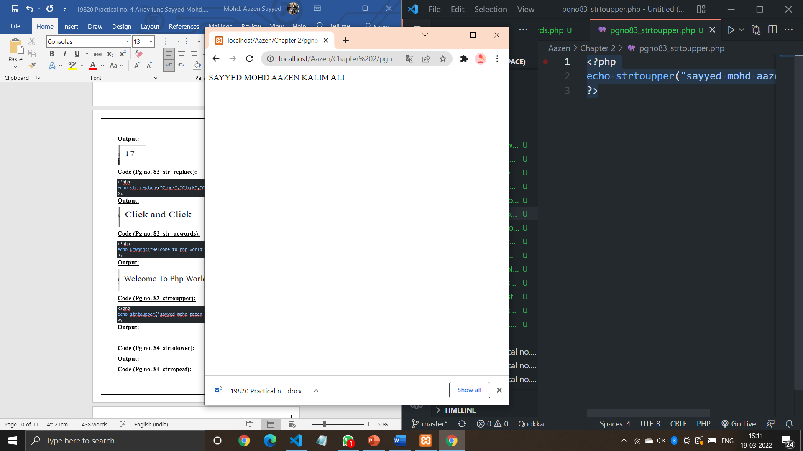

**Code (Pg no. 84_strtolower):**

<?php

echo strtolower("SAYYED MOHD AAZEN KALIM ALI");

?>

**Output:**

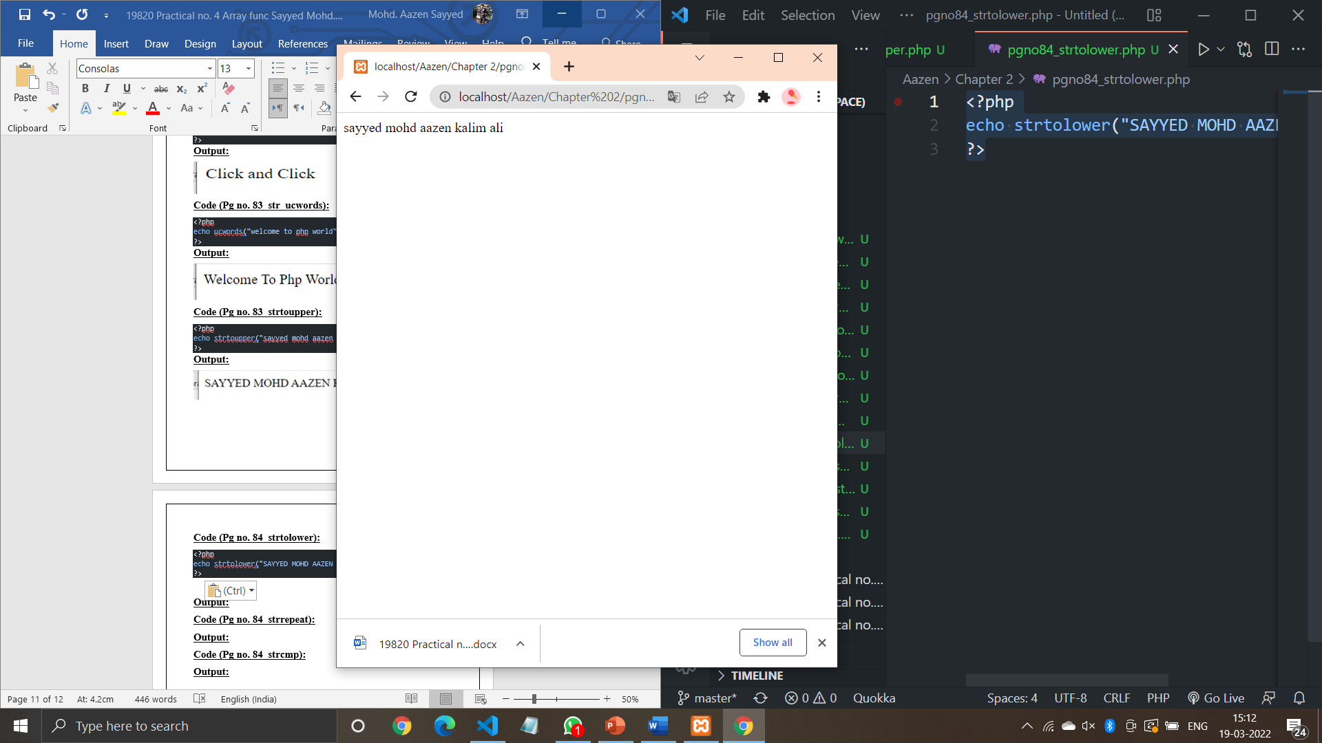

**Code (Pg no. 84_strrepeat):**

<?php

echo str_repeat("*",10);

?>

**Output:**

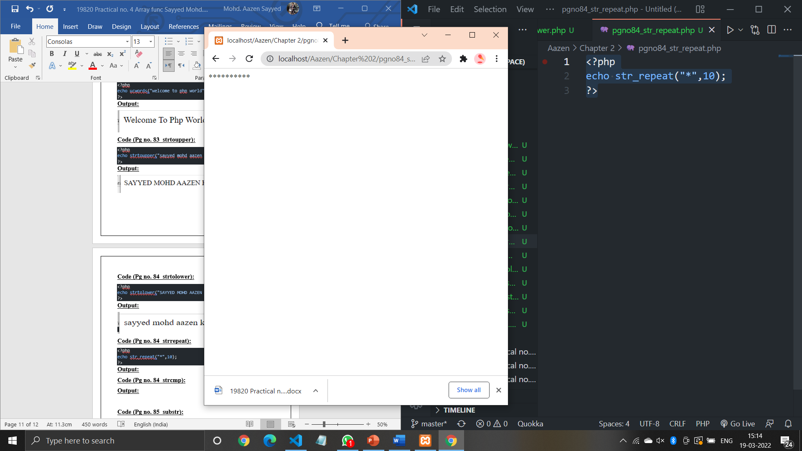

**Code (Pg no. 84_strcmp):**

<?php

echo strcmp("Hello world!","Hello world!");

echo strcmp("world!","Hello PHP!");

echo strcmp("Hello PHP!","world!");

?>

**Output:**

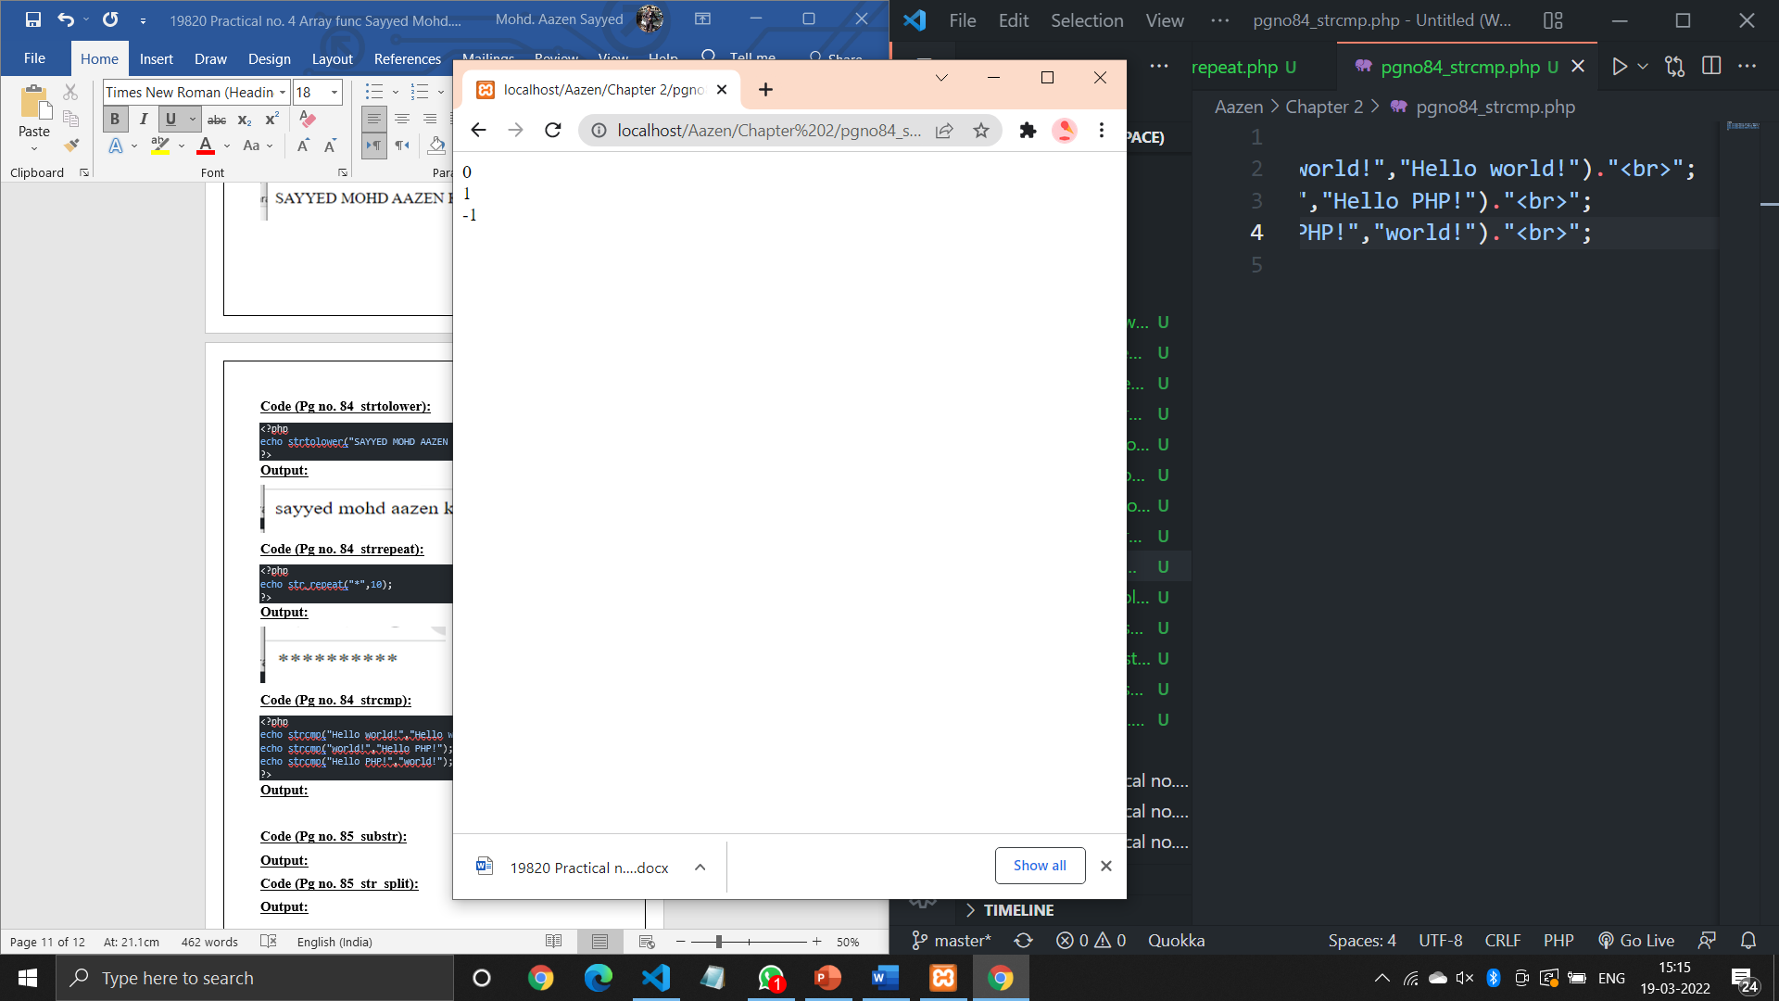

**Code (Pg no. 85_substr):**

<?php

echo substr("Welcome to PHP",11)."<br>";

echo substr("Welcome to PHP",0,7)."<br>";

?>

**Output:**

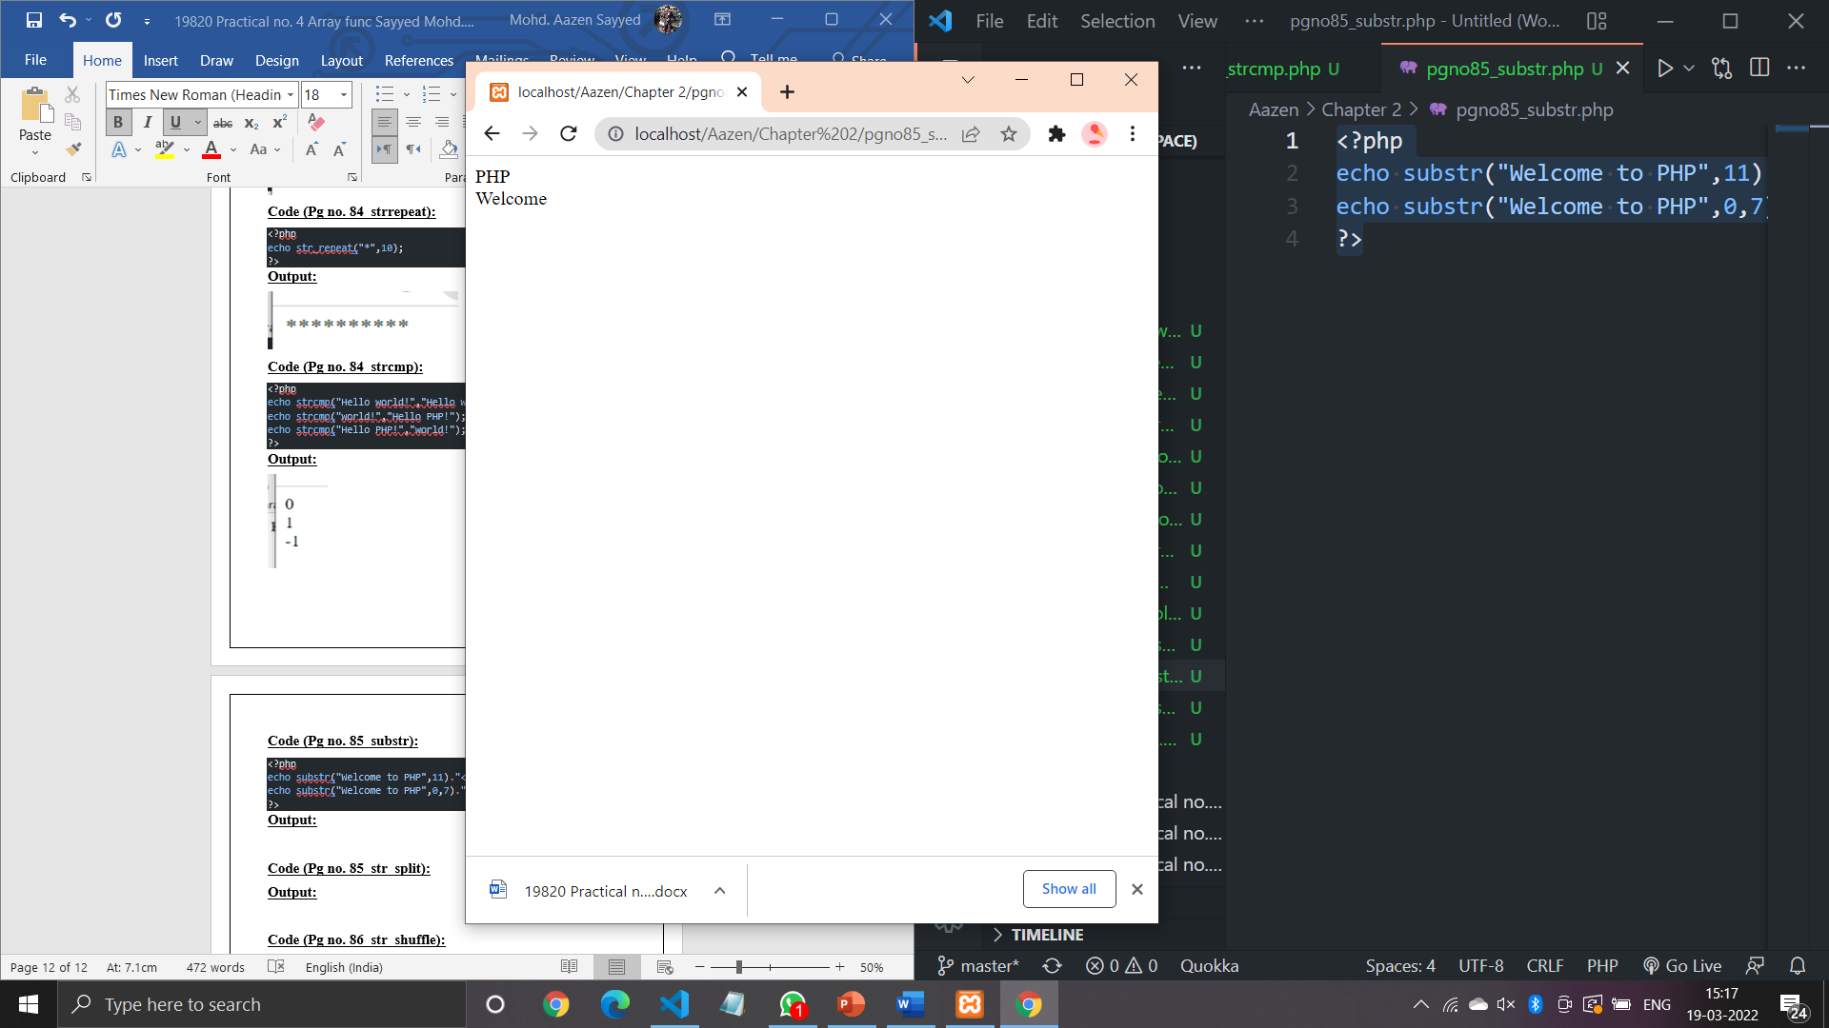

**Code (Pg no. 85_str_split):**

<?php

$str="PHP";

str_split($str);

?>

**Output:**

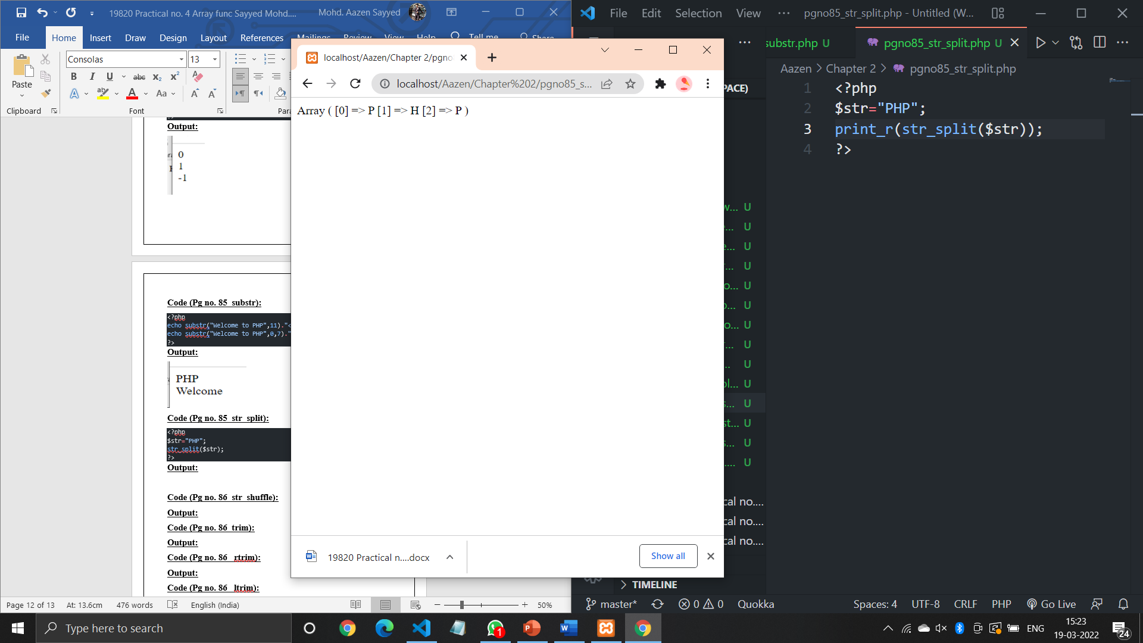

**Code (Pg no. 86_str_shuffle):**

<?php

$str="PHP";

print_r(str_shuffle($str));

?>

**Output:**

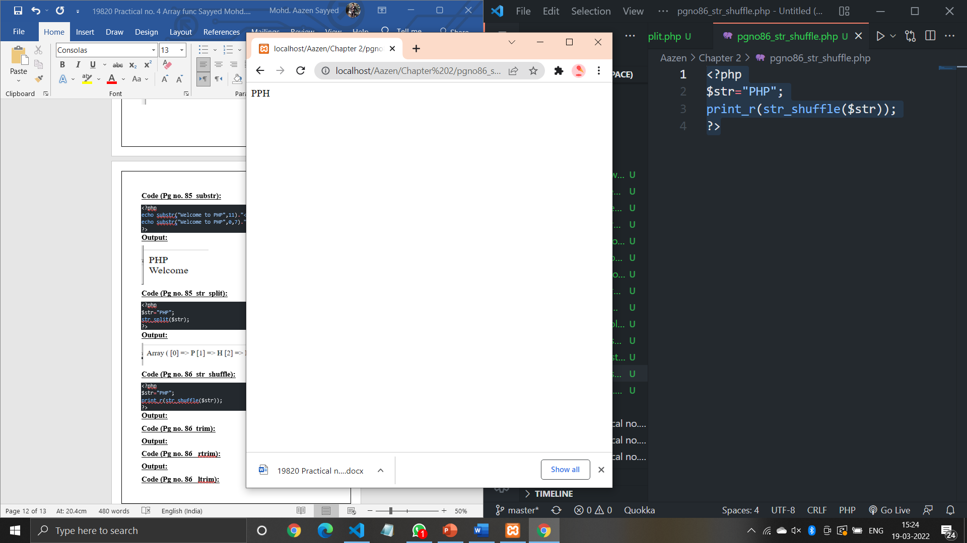

**Code (Pg no. 86_trim):**

<?php

$str="         Welcome";

echo(trim($str));

?>

**Output:**

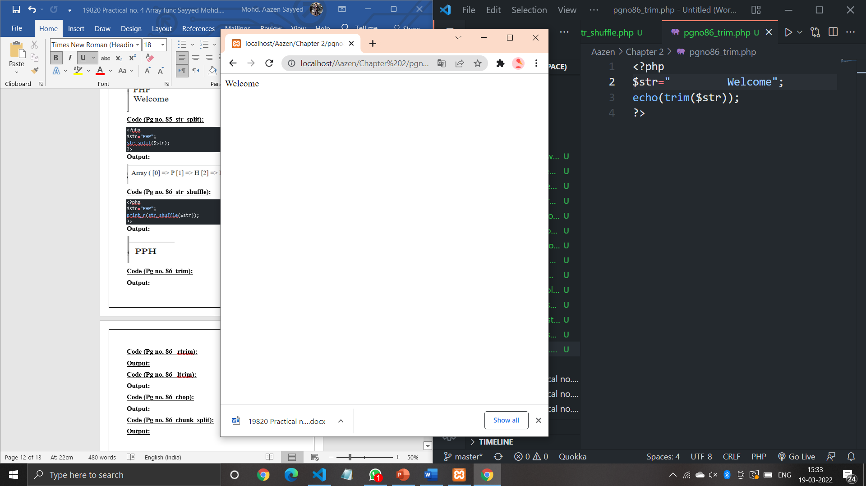

**Code (Pg no. 86_ rtrim):**

<?php

$str="Hello PHP";

print_r(rtrim($str,"PHP"));

?>

**Output:**

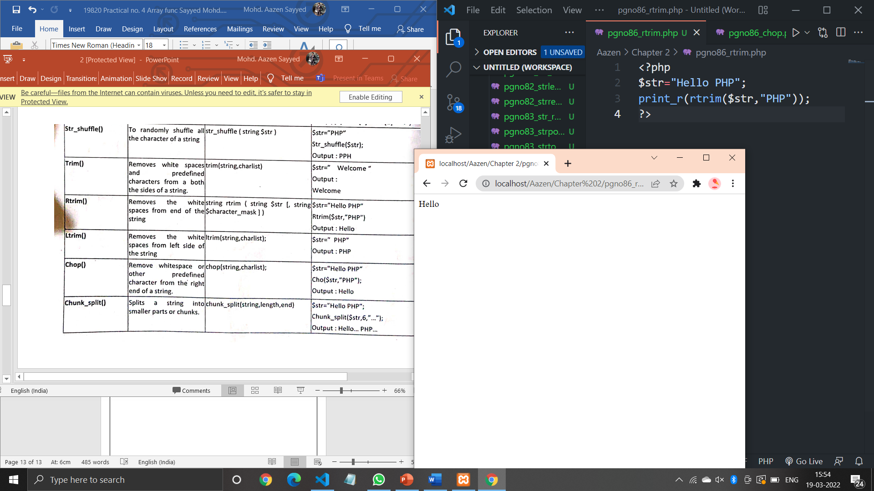

**Code (Pg no. 86_ ltrim):**

<?php

$str="Hello PHP";

print_r(ltrim($str,"Hello"));

?>

**Output:**

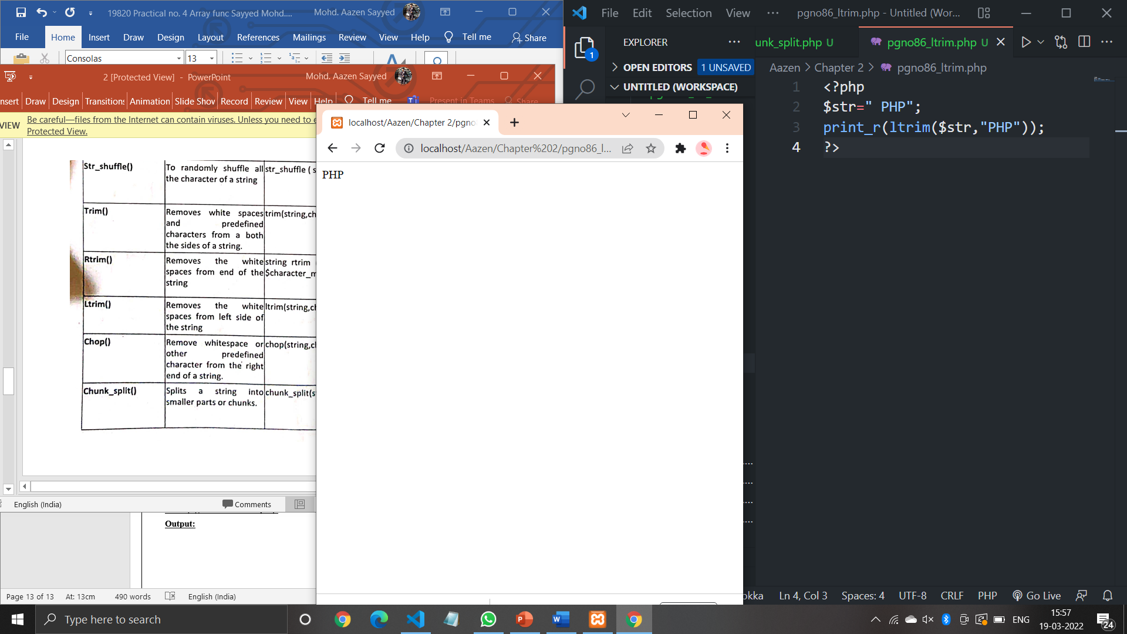

**Code (Pg no. 86_chop):**

<?php

$str="Hello PHP";

print_r(chop($str,"PHP"));

?>

**Output:**

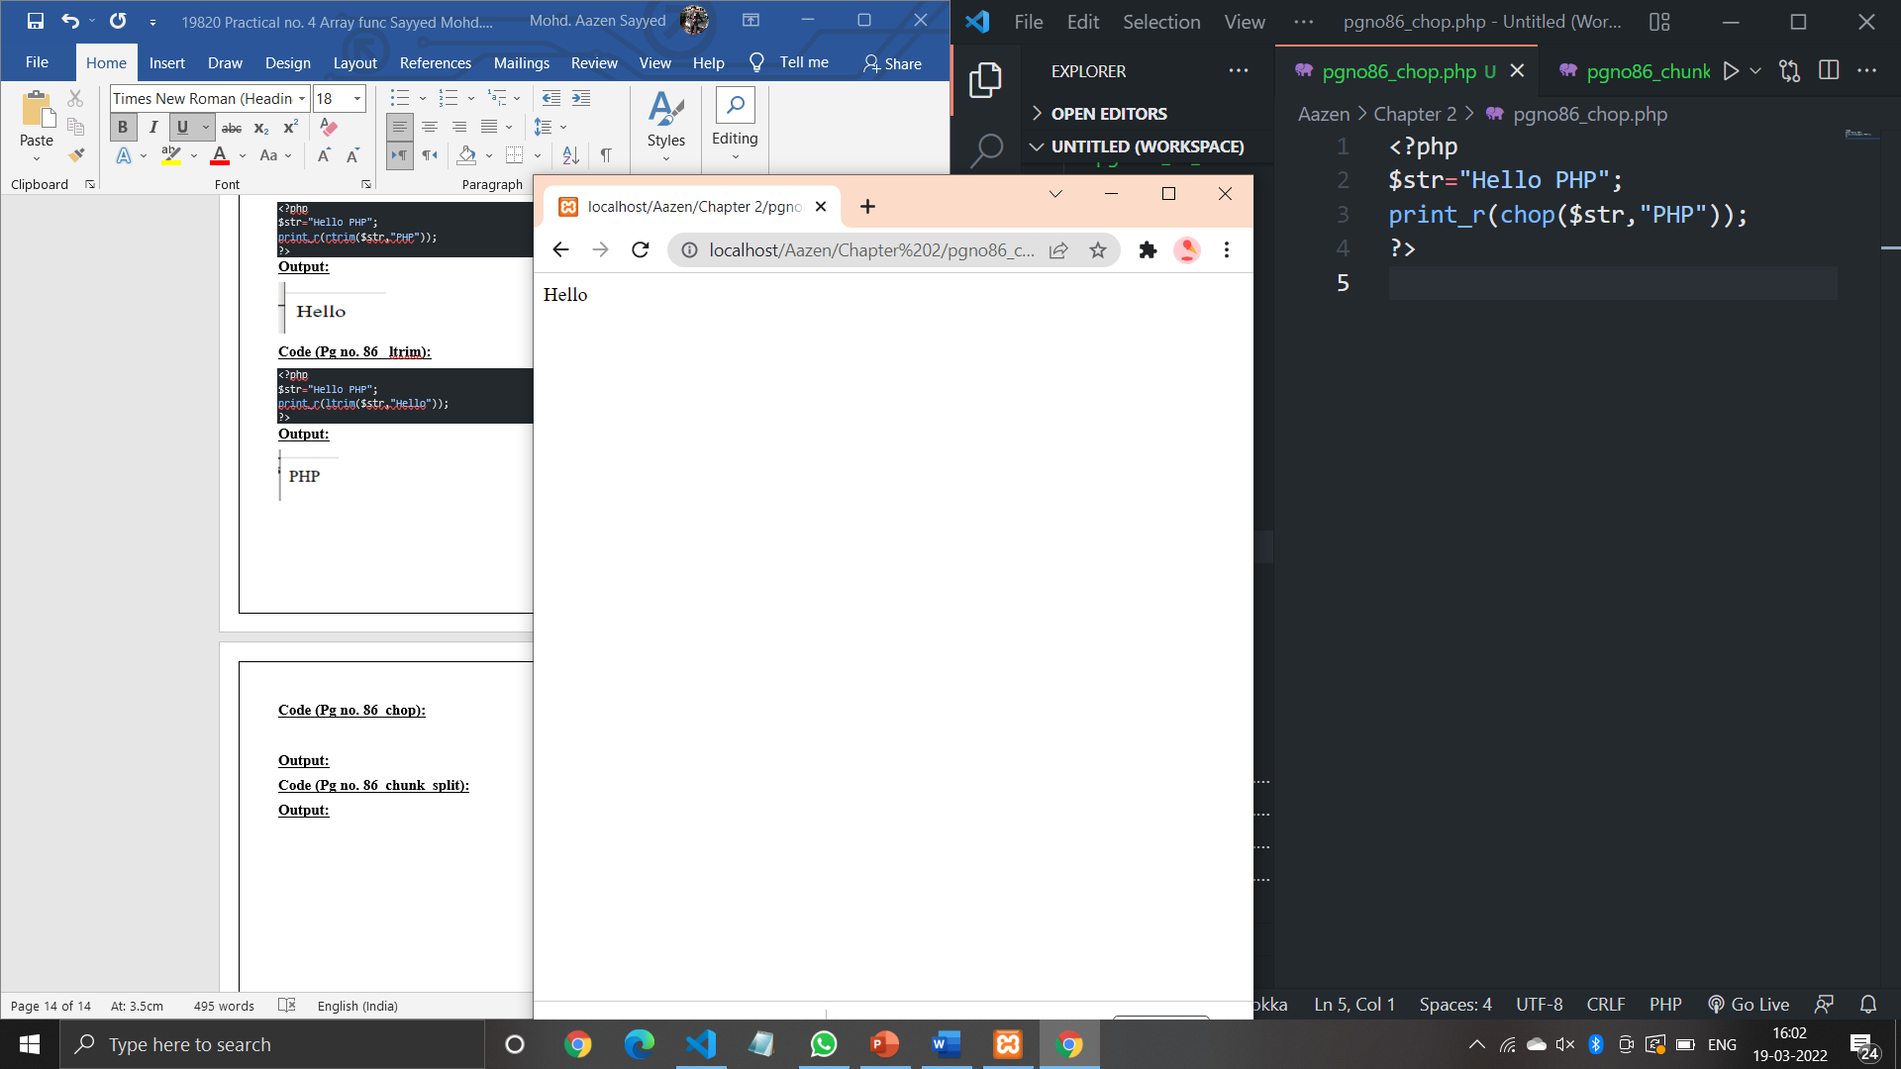

**Code (Pg no. 86_chunk_split):**

<?php

$str="Hello PHP";

print_r(chunk_split($str,6,"..."));

?>

**Output:**

